Step1:

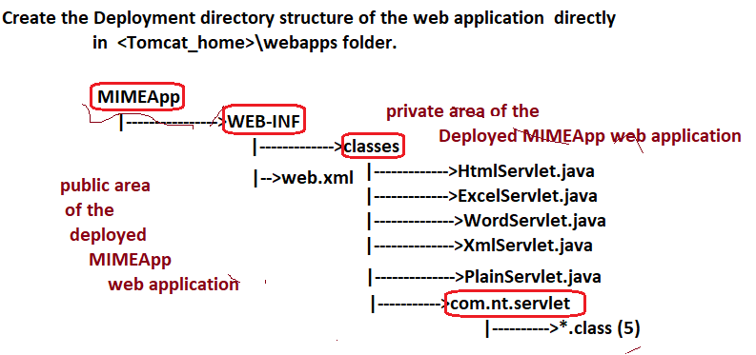

Step2: Develop the source code of Servlet components.

**2.1.FileName:-HtmlServlet.java**

package com.nt.servlet;

import java.io.*;

import jakarta.servlet.*;

import jakarta.servlet.http.*;

public class HtmlServlet extends HttpServlet{

protected void service(HttpServletRequest req, HttpServletResponse res)throws ServletException,IOException{

res.setContentType("text/html");

PrintWriter pw=res.getWriter();

pw.println("<table border='1' bgcolor='red'>");

pw.println("<tr><th>Name</th> <th>Branch</th></tr>");

pw.println("<tr><td>Name</td> <td>Branch</td></tr>");

pw.println("<tr><td>Name</td> <td>Branch</td></tr>");

pw.println("</table>");

pw.close();

}

}

**2.2.FileName:-XmlServlet.java**

package com.nt.servlet;

import java.io.*;

import jakarta.servlet.*;

import jakarta.servlet.http.*;

public class XmlServlet extends HttpServlet{

protected void service(HttpServletRequest req, HttpServletResponse res)throws ServletException,IOException{

res.setContentType("text/xml");

PrintWriter pw=res.getWriter();

pw.println("<table border='1' bgcolor='red'>");

pw.println("<tr><th>Name</th> <th>Branch</th></tr>");

pw.println("<tr><td>Name</td> <td>Branch</td></tr>");

pw.println("<tr><td>Name</td> <td>Branch</td></tr>");

pw.println("</table>");

pw.close();

}

}

**2.3.FileName:-PlainServlet.java**

package com.nt.servlet;

import java.io.*;

import jakarta.servlet.*;

import jakarta.servlet.http.*;

public class PlainServlet extends HttpServlet{

protected void service(HttpServletRequest req, HttpServletResponse res)throws ServletException,IOException{

res.setContentType("text/plain");

PrintWriter pw=res.getWriter();

pw.println("<table border='1' bgcolor='red'>");

pw.println("<tr><th>Name</th> <th>Branch</th></tr>");

pw.println("<tr><td>Name</td> <td>Branch</td></tr>");

pw.println("<tr><td>Name</td> <td>Branch</td></tr>");

pw.println("</table>");

pw.close();

}

}

**2.4.FileName:-WordServlet.java**

package com.nt.servlet;

import java.io.*;

import jakarta.servlet.*;

import jakarta.servlet.http.*;

public class WordServlet extends HttpServlet{

protected void service(HttpServletRequest req, HttpServletResponse res)throws ServletException,IOException{

res.setContentType("application/vnd.ms-word");

PrintWriter pw=res.getWriter();

pw.println("<table border='1' bgcolor='red'>");

pw.println("<tr><th>Name</th> <th>Branch</th></tr>");

pw.println("<tr><td>Name</td> <td>Branch</td></tr>");

pw.println("<tr><td>Name</td> <td>Branch</td></tr>");

pw.println("</table>");

pw.close();

}

}

**2.5.FileName:-ExcelServlet.java**

package com.nt.servlet;

import java.io.*;

import jakarta.servlet.*;

import jakarta.servlet.http.*;

public class ExcelServlet extends HttpServlet{

protected void service(HttpServletRequest req, HttpServletResponse res)throws ServletException,IOException{

res.setContentType("application/vnd.ms-excel");

PrintWriter pw=res.getWriter();

pw.println("<table border='1' bgcolor='red'>");

pw.println("<tr><th>Name</th> <th>Branch</th></tr>");

pw.println("<tr><td>Name</td> <td>Branch</td></tr>");

pw.println("<tr><td>Name</td> <td>Branch</td></tr>");

pw.println("</table>");

pw.close();

}

}

**Step3:** Configure the all servlets components inweb.xml file.

<web-app>

<servlet>

<servlet-name>html</servlet-name>

<servlet-class>com.nt.servlet.HtmlServlet</servlet-class>

</servlet>

<servlet-mapping>

<servlet-name>html</servlet-name>

<url-pattern>/html</url-pattern>

</servlet-mapping>

<servlet>

<servlet-name>xml</servlet-name>

<servlet-class>com.nt.servlet.XmlServlet</servlet-class>

</servlet>

<servlet-mapping>

<servlet-name>xml</servlet-name>

<url-pattern>/xml</url-pattern>

</servlet-mapping>

<servlet>

<servlet-name>plain</servlet-name>

<servlet-class>com.nt.servlet.PlainServlet</servlet-class>

</servlet>

<servlet-mapping>

<servlet-name>plain</servlet-name>

<url-pattern>/plain</url-pattern>

</servlet-mapping>

<servlet>

<servlet-name>excel</servlet-name>

<servlet-class>com.nt.servlet.ExcelServlet</servlet-class>

</servlet>

<servlet-mapping>

<servlet-name>excel</servlet-name>

<url-pattern>/excel</url-pattern>

</servlet-mapping>

<servlet>

<servlet-name>word</servlet-name>

<servlet-class>com.nt.servlet.WordServlet</servlet-class>

</servlet>

<servlet-mapping>

<servlet-name>word</servlet-name>

<url-pattern>/word</url-pattern>

</servlet-mapping>

</web-app>

**Step4:**- Compile all servlet components.

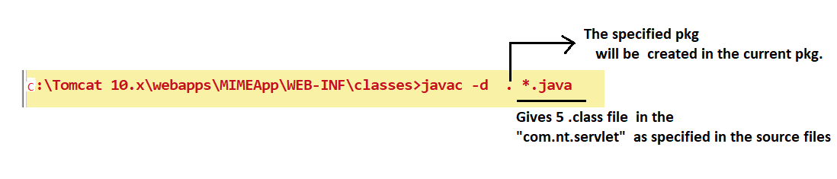

Step5:- Start the Tomcat server.

Step6:- Test the Application from browser.